NATIONAL COMMUNICATIONS AUTHORITY

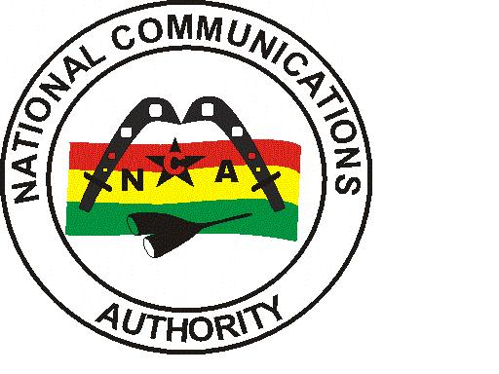

**AIRTELTIGO 3G COVERAGE REPORT – GREATER ACCRA REGION**

|  |
| --- |
| Test conducted | April 2022 |

**Contents**

List of Figures 1

List of Tables 1

1.0 EXECUTIVE SUMMARY 2

1.1 METHODOLOGY 2

1.2 FINDINGS AND ANALYSIS 3

1.2.1 Test Locations 3

1.2.2 Coverage Status 4

1.2.3 3G Coverage Plot 5

1.2.4 RSCP Sampling Distribution 9

1.3 CONCLUSION 9

## List of Figures

Figure 1. 3G Coverage Plot – Abokobi 5

Figure 3. 3G Coverage Plot – Adenta 6

Figure 4. 3G Coverage Plot – Amasaman 6

Figure 5. 3G Coverage Plot – Dansoman 7

Figure 6. 3G Coverage Plot – Madina 7

Figure 7. 3G Coverage Plot – Kokomlele 8

Figure 8. 3G Coverage Plot – Sowutuom 8

Figure 8. 3G Coverage Plot – Sowutuom 8

Figure 8. 3G Coverage Plot – Sowutuom 8

Figure 8. 3G Coverage Plot – Sowutuom 8

Figure 8. 3G Coverage Plot – Sowutuom 8

Figure 8. 3G Coverage Plot – Sowutuom 8

Figure 8. 3G Coverage Plot – Sowutuom 8

Figure 8. 3G Coverage Plot – Sowutuom 8

Figure 9. 3G Coverage Samples Plot 9

## List of Tables

Table 1: Signal Strength Range 2

Table 2: 3G Coverage Assessment Schedule and Test Locations 3

Table 3: Coverage Status and Average Signal strength for each test location 4

## 1.0 EXECUTIVE SUMMARY

Clause 6.4 of Annex A of the 3G Licence directs the Licensee to roll-out 3G deployment across all Metropolitan, Municipal and District capitals of the country within five (5) years after the effective date of the Licence. In order to monitor and ensure compliance of coverage obligations, a 3G Coverage verification campaign was carried out from 10th March to 11th April 2022 in Fourteen (14) District Capitals in the GREATER ACCRA Region. The findings of the audit exercise revealed AIRTELTIGO’s 3G coverage presence in thirteen(13) out of fourteen (14) tested district capitals; with coverage improvement required in some communities.

## 1.1 METHODOLOGY

The methodology used in this exercise relied on field tests performed using NEMO INVEX II for data collection.

Measurement samples were collected in idle 3G-locked drive-test mode along pre-defined route within each district capital in the Greater Accra Region.

Network coverage assessment was made by measuring the downlink signal levels, CPICH RSCP (Common Pilot Channel Received Signal Code Power) for WCDMA/UMTS services.

The main indicators used for this exercise was based on parameters below:

* Signal Strength (dBm)
* Coverage Status

Generally, the signal strength as seen in NEMO WIND CATCHER is shown below:

Table 1: Signal Strength Range

|  |  |  |  |  |
| --- | --- | --- | --- | --- |
| Radio Access Technology | Signal Strength Range (dBm) | | | |
| WCDMA (3G) | -105>RSCP | –105≤ RSCP < -95 | –95≤ RSCP< –85 | –85 ≤RSCP < –20 |
| Rating | Non-existent | Poor | Fair | Good |

The essence of the idle 3G-locked mode of coverage sample collection was to obtain on the average a signal strength measurement which is representative of the coverage situation in each of the district capital that was driven.

A “**Not Covered**” coverage status is rated on the basis that either a “No WCDMA signal” was detected by the measurement system or the average RSCP level obtained was less than -105 dBm as stipulated under Section 1.5 of Annex A of the 3G Licence.

A “**Not Maintained**” coverage status is rated on the basis that even though a “No WCDMA signal” was detected or RSCP level obtained was less than -105 dBm, an independent analysis by the Authority confirmed that coverage had existed but was not maintained at the period of the drive.

## 1.2 FINDINGS AND ANALYSIS

## 1.2.1 Test Locations

The 3G monitoring exercise was started in the Greater Accra Region on 11th March 2022 at 10:22am and ended on 9th April 2022 at 11:20am.

The test was conducted on perceived busy hour periods depending on the social and business activities and subscriber behaviour in the Region. Test was carried out every day for four (4) days in each District Capital.

Table 2 below indicates detailed locations and times at which the tests were conducted.

Table 2: 3G Coverage Assessment Schedule and Test Locations

| CLUSTER | DATE | TIME | DRIVEN ROUTE |
| --- | --- | --- | --- |
| A | 11/03/2022 | 10:22 am - 01:22 pm | Adenta |
| B | 11/03/2022 | 05:36 pm - 07:37 pm | Abokobi |
| C | 12/03/2022 | 07:58 am - 11:05 am | Adenta |
| D | 12/03/2022 | 05:58 pm - 07:59 pm | Abokobi |
| E | 13/03/2022 | 07:55 am - 10:58 am | Adenta |
| F | 13/03/2022 | 02:38 pm - 04:38 pm | Abokobi |
| G | 14/03/2022 | 02:21 pm - 03:33 pm | La |
| H | 14/03/2022 | 12:00 pm - 03:03 pm | Adenta |
| I | 14/03/2022 | 03:22 pm - 05:28 pm | Abokobi |
| J | 15/03/2022 | 10:19 am - 12:39 pm | Nungua |
| K | 15/03/2022 | 10:30 am - 12:27 pm | Amasaman |
| L | 15/03/2022 | 04:02 pm - 05:35 pm | La |
| M | 16/03/2022 | 08:13 am - 09:39 am | La |
| N | 16/03/2022 | 09:08 am - 11:46 am | Amasaman |
| O | 16/03/2022 | 02:44 pm - 05:09 pm | Nungua |
| P | 17/03/2022 | 06:43 am - 08:22 am | La |
| Q | 17/03/2022 | 08:58 am - 11:21 am | Amasaman |
| R | 17/03/2022 | 04:07 pm - 05:56 pm | Nungua |
| S | 18/03/2022 | 09:16 am - 11:44 am | Amasaman |
| T | 18/03/2022 | 09:54 am - 12:35 pm | Nungua |
| U | 21/03/2022 | 10:26 am - 11:59 am | Tema |
| V | 22/03/2022 | 09:37 am - 12:13 pm | Dansoman |
| W | 22/03/2022 | 12:17 pm - 01:40 pm | Sege |
| X | 22/03/2022 | 04:03 pm - 05:29 pm | Tema |
| Y | 22/03/2022 | 04:08 pm - 06:59 pm | Sowutuom |
| Z | 23/03/2022 | 08:00 am - 11:01 am | Dansoman |
| AA | 23/03/2022 | 01:27 pm - 02:48 pm | Sege |
| AB | 23/03/2022 | 02:43 pm - 05:43 pm | Sowutuom |
| AC | 23/03/2022 | 05:17 pm - 06:31 pm | Tema |
| AD | 24/03/2022 | 07:07 am - 10:19 am | Dansoman |
| AE | 24/03/2022 | 10:00 am - 11:13 am | Sege |
| AF | 24/03/2022 | 11:30 am - 10:57 pm | Sowutuom |
| AG | 24/03/2022 | 02:42 pm - 04:04 pm | Tema |
| AH | 25/03/2022 | 08:07 am - 11:08 am | Dansoman |
| AI | 25/03/2022 | 02:25 pm - 03:30 pm | Sege |
| AJ | 25/03/2022 | 02:52 pm - 06:05 pm | Sowutuom |
| AK | 28/03/2022 | 09:22 am - 02:45 pm | Madina |
| AL | 28/03/2022 | 04:51 pm - 06:30 pm | Dodowa |
| AM | 29/03/2022 | 08:18 am - 01:38 pm | Madina |
| AN | 29/03/2022 | 02:23 pm - 03:45 pm | Dodowa |
| AO | 30/03/2022 | 09:12 am - 02:50 pm | Madina |
| AP | 30/03/2022 | 01:04 pm - 02:56 pm | Kpone |
| AQ | 30/03/2022 | 05:07 pm - 06:32 pm | Dodowa |
| AR | 31/03/2022 | 09:27 am - 02:57 pm | Madina |
| AS | 31/03/2022 | 01:38 pm - 03:18 pm | Kpone |
| AT | 31/03/2022 | 05:57 pm - 07:16 pm | Dodowa |
| AU | 01/04/2022 | 08:51 am - 10:41 am | Prampram |
| AV | 01/04/2022 | 03:05 pm - 04:42 pm | Kpone |
| AW | 02/04/2022 | 08:15 am - 10:02 am | Prampram |
| AX | 02/04/2022 | 11:59 am - 01:53 pm | Kpone |
| AY | 03/04/2022 | 06:29 am - 08:07 am | Prampram |
| AZ | 04/04/2022 | 08:10 am - 10:07 am | Prampram |
| BA | 06/04/2022 | 09:21 am - 11:31 am | Kokomlemle |
| BB | 07/04/2022 | 09:14 am - 11:23 am | Kokomlemle |
| BC | 08/04/2022 | 09:03 am - 11:23 am | Kokomlemle |
| BD | 09/04/2022 | 08:48 am - 11:20 am | Kokomlemle |

## 

## 1.2.2 Coverage Status

Table 3: Coverage Status and Average Signal strength for each test location

| No. | District Capital | Average RSCP (≥ -105dBm) | | | | Coverage Status |
| --- | --- | --- | --- | --- | --- | --- |
| Day 1 | Day 2 | Day 3 | Day 4 |
| 1 | Abokobi | -74.63 | -78.33 | -79.62 | -76.79 | Good network coverage in Abokobi. However, major network coverage improvement is required around Abokobi Royal Porter’s City Church, around the Hillview Guest Center and the Abokobi Presbyterian Church. |
| 2 | Adenta | -84.37 | -82.27 | -82.92 | -80.87 | Good Network Coverage in Adenta. However, major network coverage improvement is needed in areas around De Youngsters School and to the East of the Adjei Onanor Avenue. |
| 3 | Amasaman | -86.77 | -87.34 | -87.94 | -87.44 | Fair network coverage in Amasaman. Major network coverage improvement is needed at the Night Market and the Apostolic Academy. |
| 4 | Dansoman | -70.76 | -75.27 | -72.48 | -73.01 | Good Network Coverage in Dansoman. Major network coverage improvement is required in and around the Holy Light International Church, behind the Darkuman Police Station and around the St. Mark Methodist Chapel. |
| 5 | Dodowa | -90.48 | -90.48 | -90.48 | -90.48 | Fair network coverage in Dodowa. Major network coverage improvement is needed around the Baba Yara Primary and JHS and around the Albany Specialist Clinic. |
| 6 | Kokomlemle | -74.85 | -74.74 | -78.95 | -76.36 | Good Network Coverage in Kokomlele. Major network coverage improvement is required on the Hilla Limann Highway close to the 2nd Kwao Link. |
| 7 | Kpone | -83.06 | -82.60 | -82.12 | -79.97 | Good network coverage in Kpone. Major network coverage improvement is required around the Western portion of the Beach Drive and on the Nautical Street. |
| 8 | Madina | -74.23 | -74.23 | -73.95 | -74.09 | Good network coverage in Madina. |
| 9 | Nungua | -75.67 | -75.38 | -77.71 | -78.38 | Good network coverage in Nungua. |
| 10 | Prampram | -83.31 | -81.03 | -80.87 | -82.45 | Good network coverage in Prampram. |
| 11 | Sege | -74.36 | -73.34 | -74.51 | -73.42 | Good network coverage in Sege. |
| 12 | Sowutuom | -77.25 | -75.90 | -77.08 | -78.99 | Good network coverage in Sowutuom. |
| 13 | Tema | -71.74 | -69.64 | -70.50 | -70.63 | Good network coverage in Tema. |
| 14 | La | -69.26 | -70.16 | -71.79 | -73.92 | Good Network Coverage in La. Major network coverage improvement is required around the Parkview Plaza on the Krakue Road and around the Kingdom Books and Stationery Limited. |

## 1.2.3 3G Coverage Plot

Figure 1. 3G Coverage Plot – Abokobi

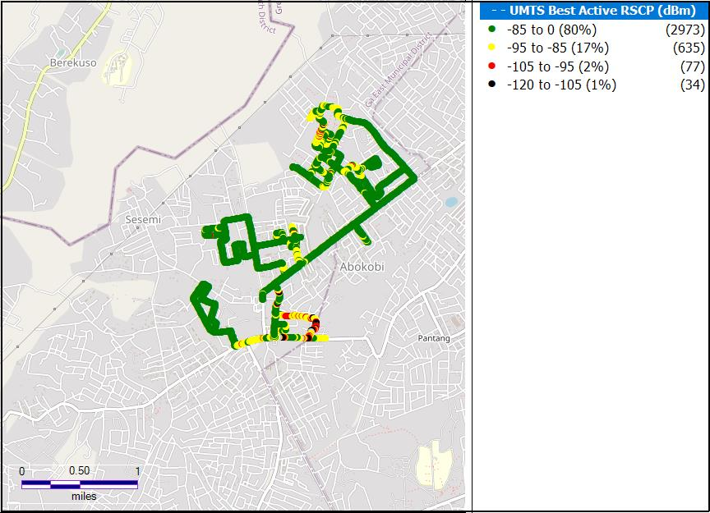

**Remarks:** Good network coverage in Abokobi. However, major network coverage improvement is required around Abokobi Royal Porter’s City Church, around the Hillview Guest Center and the Abokobi Presbyterian Church.

Figure 2. 3G Coverage Plot – Adenta

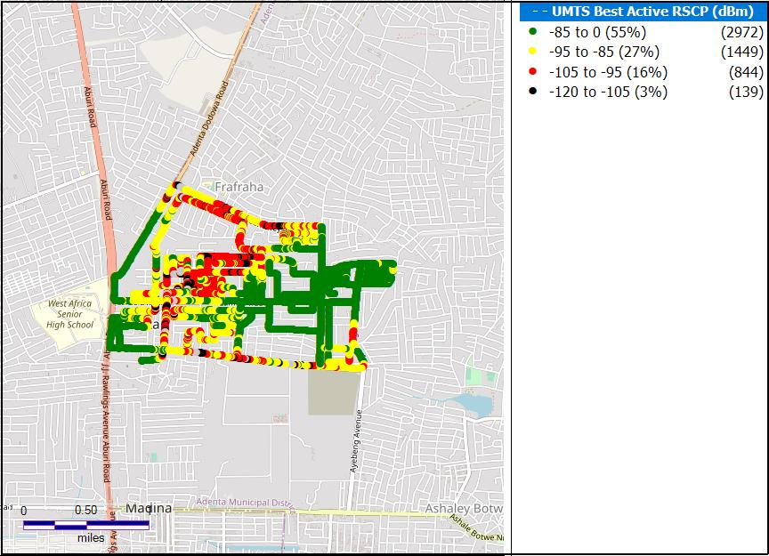

**Remarks:** Good Network Coverage in Adenta. However, major network coverage improvement is needed in areas around SSNIT flat ,Unity International college and Fafraha community senior high school.

Figure 3. 3G Coverage Plot – Amasaman

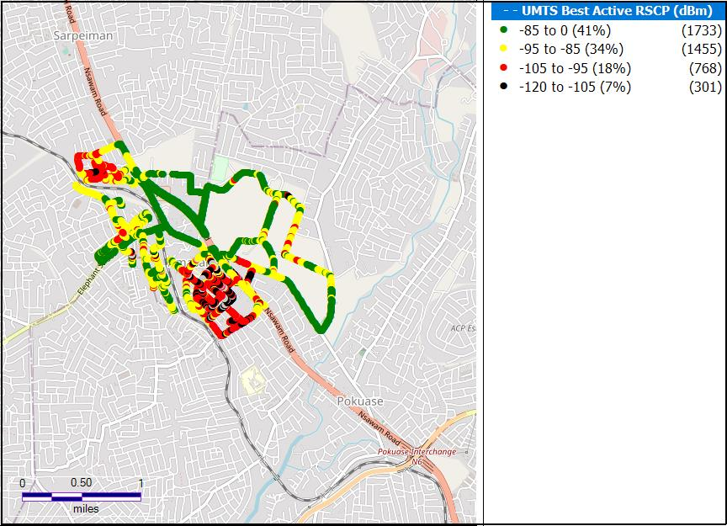

**Remarks:** Fair network coverage in Amasaman. Major network coverage improvement is needed at the Amasaman hospital and the Ga west Municipal Assembly.

Figure 4. 3G Coverage Plot – Dansoman

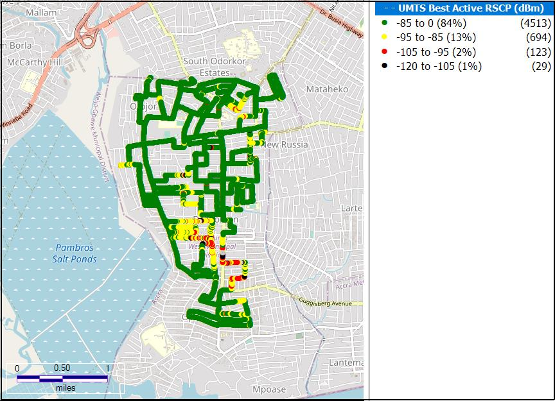

**Remarks:** Good Network Coverage in Darkuman. Major network coverage improvement is required in and around the Datus Complex school.

Figure 5. 3G Coverage Plot – Madina

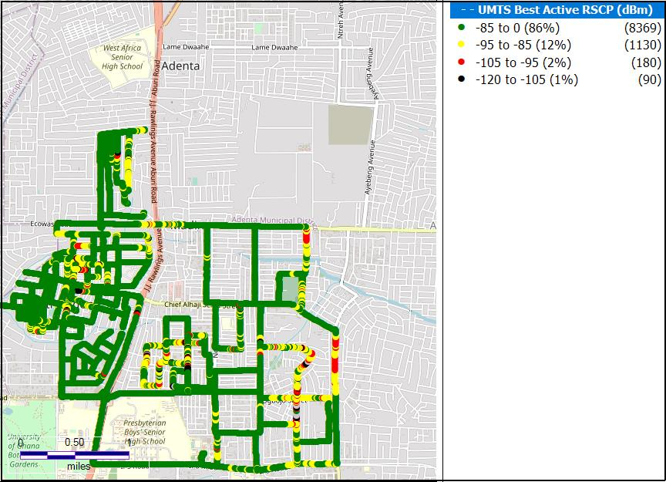

**Remarks:** Good network coverage in Madina. Major network coverage improvement is needed around Ogbojo total fuel station and JHS and around the Action Progressive institute.

Figure 6. 3G Coverage Plot – Kokomlele

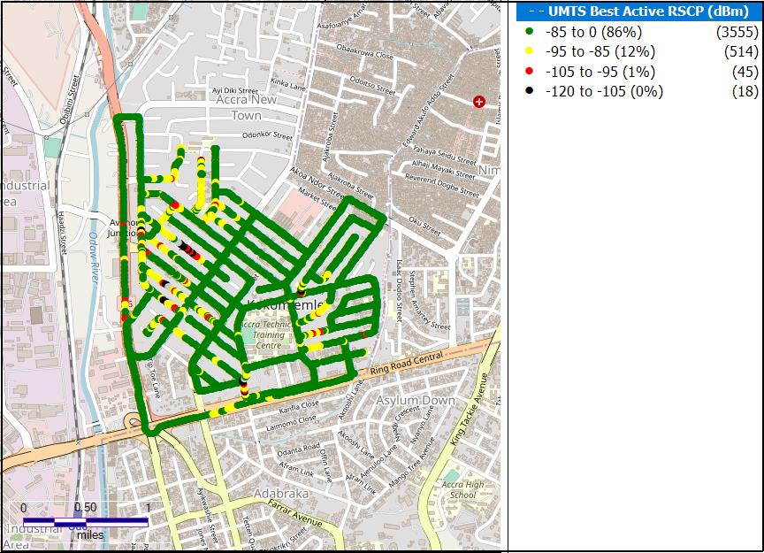

**Remarks:** Good Network Coverage in Kokomlele. Major network coverage improvement is required on the Goodwill Road and around Hubtel.

Figure 7. 3G Coverage Plot – Kpone

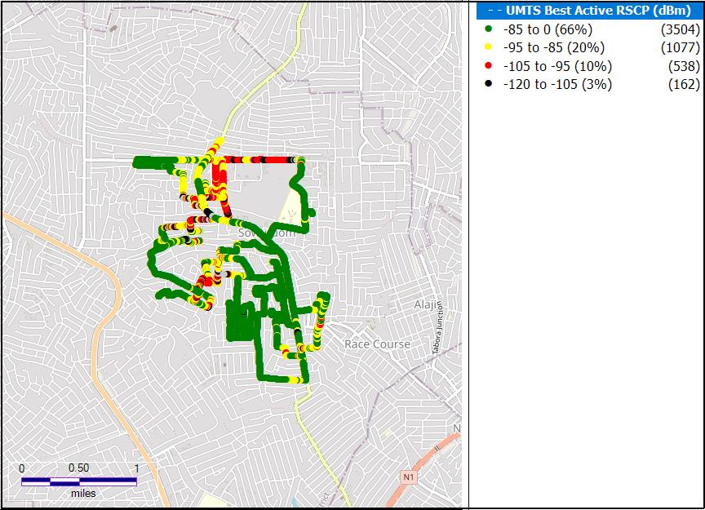

**Remarks:** Good network coverage in Nungua. Major network coverage improvement is required around the Western portion of the Beach Drive and on the Nautical Street.

Figure 8. 3G Coverage Plot – Dodowa

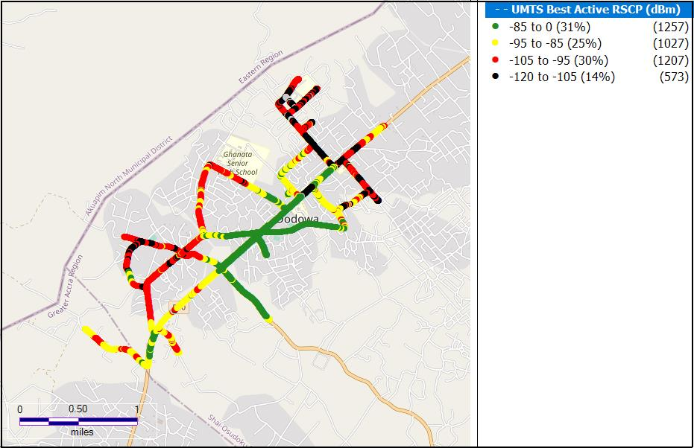**Remarks:** Fair network coverage in Dodowa. However, major network improvement is needed around Ghana secondary school, Dodowa health research centre and Dodowa new town basic school.

Figure 9. 3G Coverage Plot -LA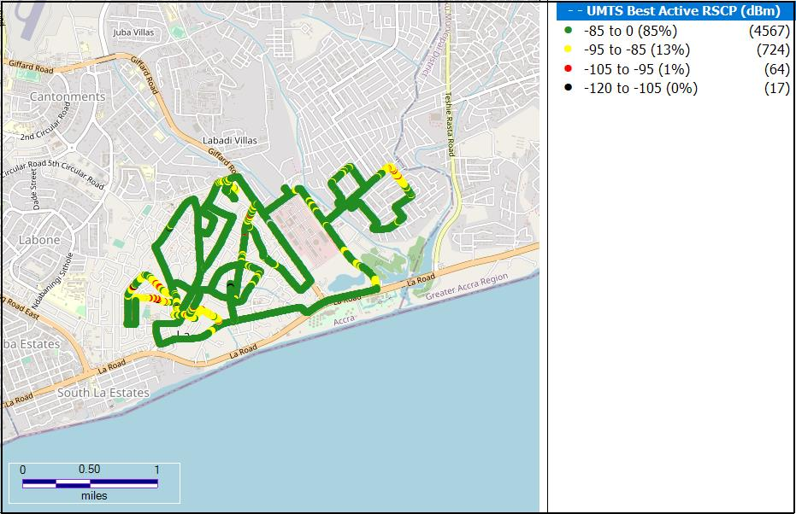**Remarks:** Good network coverage in La. However, major network improvement is needed in on and around the By Pass road and the La Presbyterian Senior high school.

Figure 10. 3G Coverage Plot – Nungua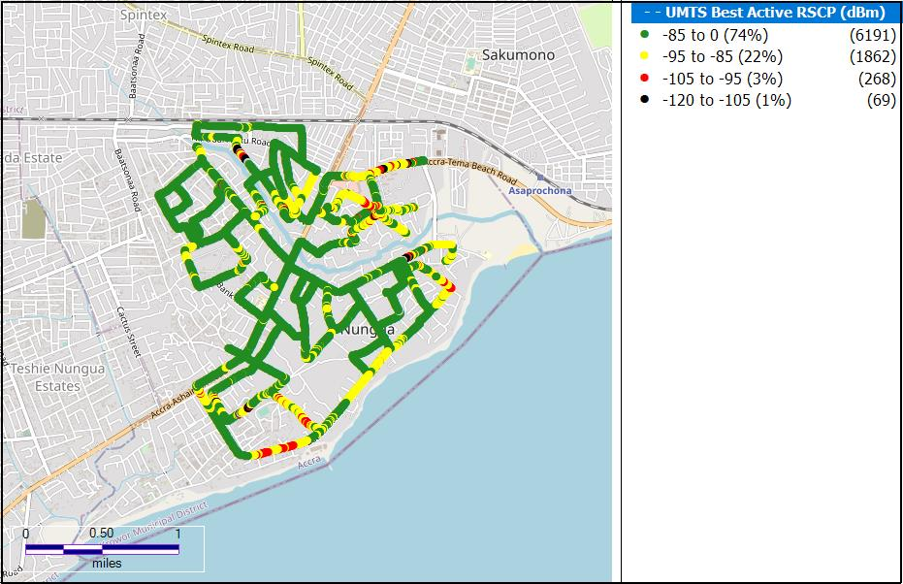**Remarks:** Good network coverage in Nungua.

Figure 11. 3G Coverage Plot – Prampram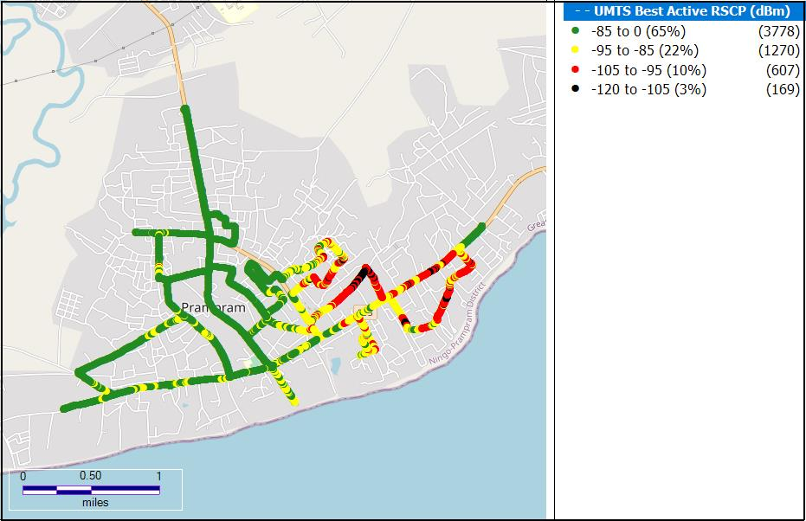**Remarks:** Good network coverage in Prampram. However , Major network improvement is needed around Ocean gate reaort and event centre.

Figure 12. 3G Coverage Plot – Sege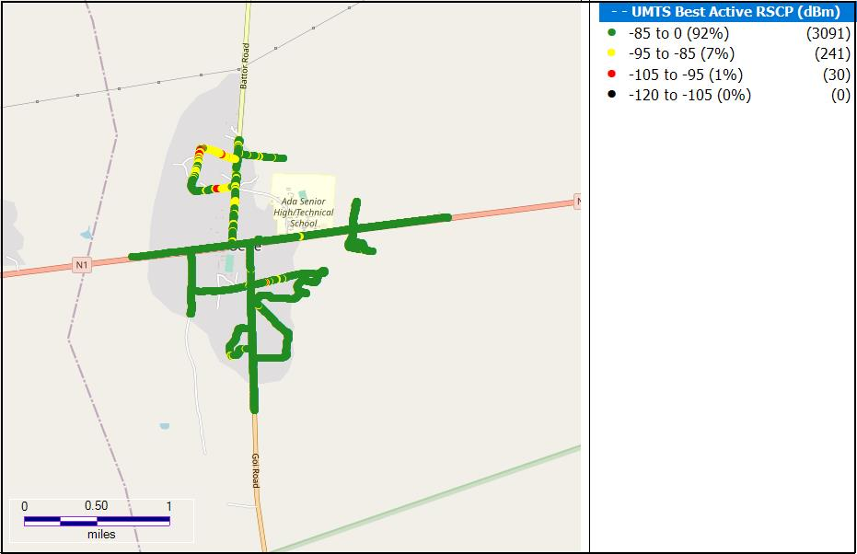**Remarks:** Good network coverage in Sege. However minor improvements needed around Apostolic Faith church, Sege Ada.

Figure 13. 3G Coverage Plot – Tema Commuinity 1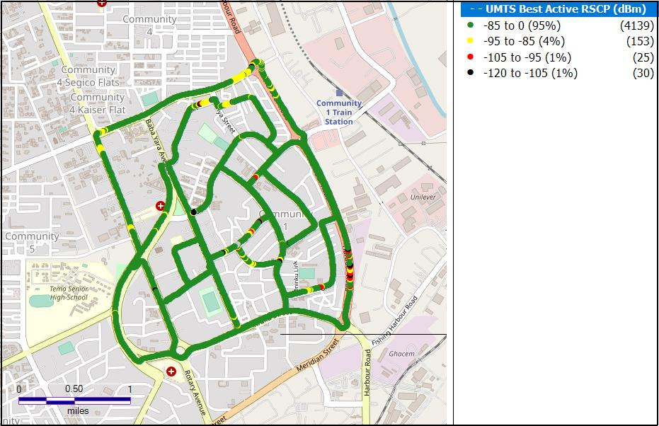**Remarks:** Good network coverage in Tema.

Figure 14. 3G Coverage Plot – SowutuomMap

Description automatically generated

**Remarks:** Good network Coverage in Sowutuom. Major network coverage improvement is required around

## 1.2.4 RSCP Sampling Distribution

Figure 15. 3G Coverage Samples Plot

**Remarks:** AIRTELTIGO recorded highest count of RSCP samples in the range –85 ≤RSCP < –20 dBm however, major improvement is required in the 16.5% of samples that are out of Good coverage.

## CONCLUSION

* AIRTELTIGO has 3G coverage in all the eight (8) District Capitals tested in the Greater Accra Region.
* AIRTELTIGO requires major 3G coverage improvement in all the district capitals tested with the exception of Nima where minor improvements are needed.